The Hart Gym
Team 2- Website Team
Product Backlog
· Creating Wireframe for Main Page
· Creating Wireframe for Sub Pages
· Get a list of machines in Hart gym
· Get main page information
· Finish HTML and CSS for main page
· Find videos regarding how to use equipment
· Finish HTML and CSS for sub pages
Highlighted Items are items in current two week block
Items in green are items that have been completed
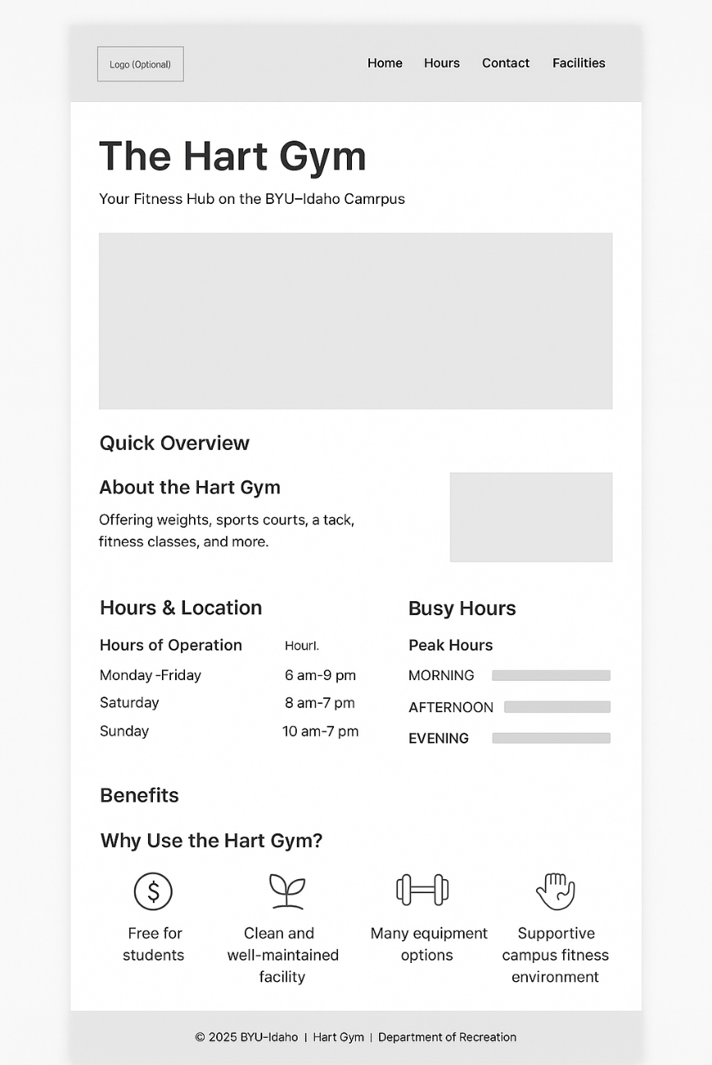
Header tabs: Home Equipment Training

PAGE 1 INFO:
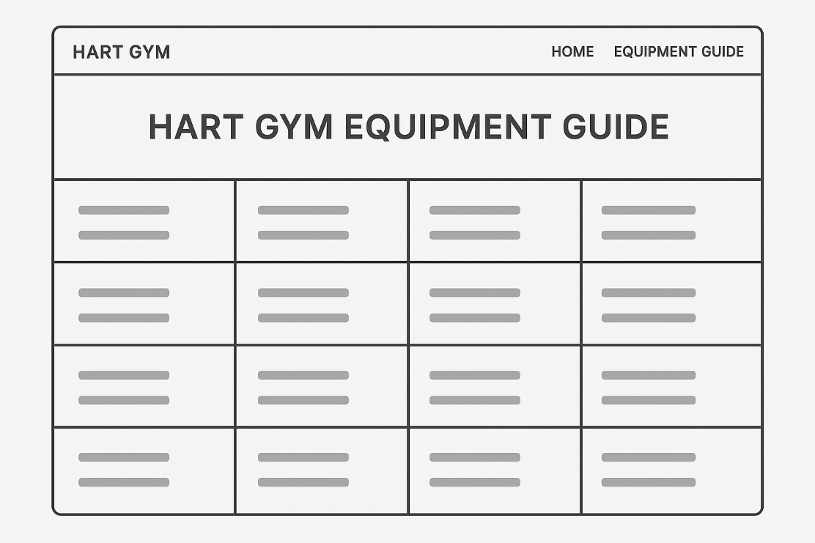
Key Tips for Using Gym Machines
- Adjust Each Machine Properly: Ensure seats, pads, and attachments align with your body size to prevent injury and maximize effectiveness
- Start with Light Weights: Practice proper form before increasing resistance. Begin with 10–15 reps at a manageable weight
- Use Smooth, Controlled Movements: Avoid jerky or rushed exercises to focus on the target muscles and reduce risk of injury
- Focus on Form: Keep your back straight, avoid locking joints, and engage the intended muscles with each rep
- Leverage Machine Help: Assisted pull-up and dip machines are excellent for building strength gradually if bodyweight exercises are challenging

🦵 Lower Body Machines
Hip Adductor (Inner Thigh)
Sit with your back against the pad and legs on the outside of the pads. Squeeze your legs together slowly, then return with control.
Hip Abductor (Outer Thigh)
Sit upright with your legs inside the pads. Push your legs outward against the resistance, then return slowly.
Leg Extension (Quads)
Sit with your shins under the pad and extend your legs upward until they are straight. Lower slowly to complete the rep.
Leg Curl (Hamstrings – Seated)
Sit with your legs under the pad and curl your heels back toward the seat. Control the movement back to the start.
Kneeling Leg Curl
Kneel on the pad with one leg hooked under the roller. Curl your heel upward toward your glutes, then lower slowly.
Leg Press
Sit with your feet shoulder-width apart on the platform. Push the platform away using your legs, then return slowly until knees are bent.
Glute Machine
Place one foot on the platform behind you and keep your chest forward. Push your leg straight back, squeezing your glutes.
Prone Leg Curl
Lie face down with your heels under the pad. Curl your heels toward your glutes, then lower slowly.
V Squat
Stand with your shoulders under the pads and feet on the platform. Squat straight down, then push back up through your heels.
Seated Calf Extension
Place the balls of your feet on the platform with pads on your thighs. Raise your heels upward, then lower slowly.
Hip Thrust Machine
Sit with your upper back against the pad and feet flat on the platform. Drive your hips upward until fully extended, then lower under control.
Hack Squat
Place your back against the pad and feet on the platform. Lower into a squat, then push straight upward.

💪 Arm Machines
Bicep Curl Machine
Sit with your arms on the pads and grip the handles. Curl upward toward your shoulders, then lower slowly.
Tricep Extension Machine
Grip the handles above or in front of you. Push downward until arms are straight, then return slowly.

🧍Chest & Shoulder Machines
Chest Press
Sit with handles at chest height and press forward until your arms are extended. Return slowly.
Incline Chest Press
Sit with the seat angled back and press upward and forward. Slowly bring the handles back to chest level.
Shoulder Press
Sit with handles at shoulder height and press straight upward. Lower slowly back to the start.
Pec Fly / Rear Delt
For chest fly, bring the handles together in front of you; for rear delt, reverse the motion and pull outward. Control both directions.
Seated Bench Press
Sit with handles near chest height and press forward until arms are extended. Bring back under control.

🏋️ Back Machines
Plated Lat Pulldown
Pull the bar down toward your upper chest while keeping your back straight. Slowly return to full arm extension.
High Row
Pull the handles back toward your chest while squeezing your shoulder blades. Slowly extend your arms forward.
Seated Row
Pull the handles toward your stomach with elbows close to your sides. Slowly extend forward.
Lat Pulldown
Pull the bar down to chest level using your back and arms. Return slowly to the top.
Back Extension
Lock your feet in and hinge forward at the waist. Raise your torso back to a straight position.

🧠 Core Machines
V Crunch
Sit back against the pad and grip the handles. Crunch forward using your abs, then return slowly.
Abdominal Crunch
Sit with your feet planted and hands on the handles. Crunch your upper body forward using your core.

🏋️ Assistance & Strength Equipment
Dip/Chin Assist
Select your weight, place knees on the pad, and perform dips or pull-ups with assisted resistance.
Smith Machine
Position the bar on the tracks and unlock it by rotating. Perform controlled squats, presses, or lunges.
Power Rack
Set the barbell on safety hooks at your desired height. Use for free-weight squats, presses, and deadlifts.
Dual Adjustable Pulley
Adjust the pulleys to any height for cable exercises like rows, flys, curls, and triceps extensions.
Lat Pulldown / Seated Row Combo
Use the top bar for lat pulldowns and the lower cable for seated rows. Control both pulling motions.

🏃 Cardio Machines
Treadmill
Step onto the belt and start at a slow speed. Increase speed gradually for walking, jogging, or running.
Stair Master
Step steadily in place as the stairs rotate beneath you. Keep your posture upright and hands light on rails.
Elliptical
Step onto the pedals and move arms and legs in a smooth forward motion. Adjust resistance for intensity.
Bike
Sit with feet on pedals and start cycling. Adjust resistance and seat height for comfort.
Rower
Push with your legs, lean back slightly, and pull the handle to your chest. Reverse the motion to reset.
Ladder (Agility Ladder)
Step quickly in and out of each square using fast footwork drills. Focus on balance and coordination.

🏋️ Free Weight Areas
Flat Bench
Lie back with feet flat and perform presses with dumbbells or a barbell. Keep your back stable and controlled.
Platform
Use this area for deadlifts, Olympic lifts, and heavy compound movements. Maintain proper posture at all times.
Dumbbells (5–110 lbs)
Select a comfortable weight and use for presses, curls, rows, lunges, and more. Always lift with control.

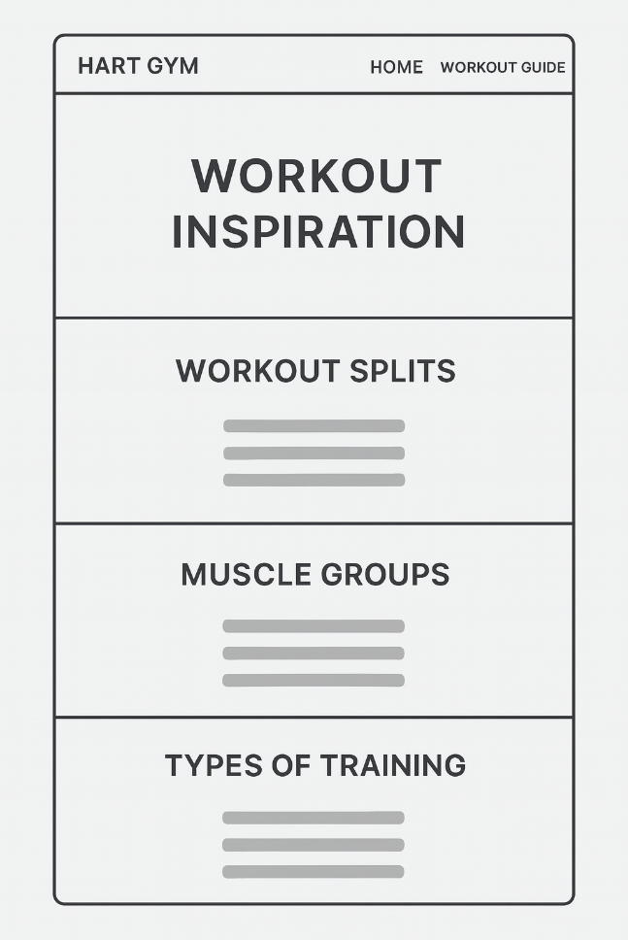
Font Awesome Dollar Sign
Sack Dollar Classic Solid Icon | Font Awesome Plant Icon
Sack Dollar Classic Solid Icon | Font Awesome Dumbbell Icon
Sack Dollar Classic Solid Icon | Font Awesome Support Icon

